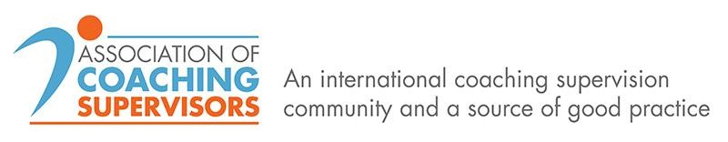
Introducing the Association of Coaching Supervisors
Coaching Supervision is increasingly being demanded by global organisations, buyers and accrediting bodies, and is fast gaining credibility and value across the coaching profession. All of the larger established associations have added value by advocating ongoing supervision for their coach members, creating codes of ethics, and launching accreditation principles and processes for supervisors. We applaud and support these developments.
The Association of Coaching Supervisors (AOCS) was set up to help in the promotion of coaching supervision to buyers, and by associations and training organisations. AoCS supports its members with self-marketing enabling them to reach their audience and contributes to our members’ ongoing learning needs.
Its remit is to:
- raise the profile of coach supervision amongst coaches and buyers of coaching
- inform and educate coaches and buyers of coaching about coach supervision and its benefits
provide an exclusive focus on coach supervision for all types of coaches, both external and
internal coaches lead a movement that influences the role and value of supervision, by developing an authoritative voice amongst the coaching profession
- position coach supervision as accessible, professional, desirable and be seen as “best practice”
- help overcome objections from coaches, and to eliminate negative connotations often associated
with the word “supervision”
provide a ‘world supervision map’ of trained supervisors accessible to buyers regionally and internationally
create an attractive range of member benefits for an annual membership fee
provide opportunities for CPD to enhance expertise through a range of quality professional practice activities, conferences, workshops, webinars, and networking, newsletters, etc.
AOCS is a not-for-profit organisation currently re-registering as a Company Limited by Guarantee This will provide us with a stronger legal framework for the future, with reduced liability for all concerned.
With a core of founding members who inform the organisation’s goals and direction, we also have a group of honorary members, advisors and volunteers who guide and mentor the development of AoCS, promote our aims and lend their support and voice where necessary.
Our aim is not to accredit supervisors, or to be a training school, or to replace existing coaching bodies/associations, but to supplement current providers, to build our relationships and to provide a real focus on supervision. Our mantra is to ‘Promote, Engage, and Develop’ our members and with the coaching community.
We continue striving to attract a range of buyers of coach supervision to quickly match their needs for locally sourced and qualified supervisors.
All involved in AOCS are passionate about supervision and wish to ensure that coaches continue to improve their skills, and to help larger organisations provide effective and continuous in-house supervision to their internal coaches. We are supported by a rosta of high profile Honorary Members and Advisers.

AoCS encourages diversity and supports inclusion across our membership. We actively welcome applications that meet our joining criteria from BAME and LGBT+ communities to come and join us.
Members are mainly qualified and accredited coaching supervisors in the UK and overseas, although a number of coaches and mentors have also joined to learn more about supervision.
We have Ambassadors in the North and South America, Asia Pacific, Australia, UK, France, Belgium, Germany, Spain, Holland, Germany, Switzerland, Austria, Czech & Slovak Republics, Russia and the Baltic States, Sweden and Ireland – and we are developing alliances and links in many developing countries.

For more information, please visit our website: https://www.associationofcoachingsupervisors.com/
Email us: info@associationofcoachingsupervisors.com
For more information, please contact Peter Welch: peter.welch@associationofcoachingsupervisors.com
We look forward to talking to you soon.
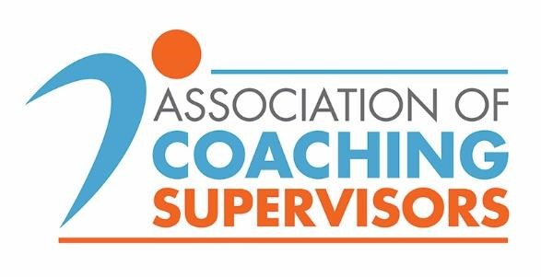
Our mission is to 'Promote, Engage, and Develop'

