Minutes of AGM/Special Gathering held on May 26th 2021
Invited: all members, plus guest Professor Stephen Palmer as guide to Transition Team.
Attended (see attendance list)
Facilitator: Peter Welch via Zoom; meeting started at 13.00 BST.
Agenda:
- Vote on becoming a professional body and a Company Limited by Guarantee (CLbG), to close the current Trade Association, allowing the board to select a suitable new bank account, to transfer the funds/assets into the new company.
- Elect Chair-Elect and Treasurer (3 year roles); announce appointment of new accountancy to oversee set up of CLbG.
- Invite interest in vacant board member roles and volunteer roles.
Minutes and decision made:
Following introductions, Peter provided a background history of AOCS’s stages of development and highlights, as context for the need to change: originally a Trade Association/unincorporated body/not a legal entity or recognized by financial institutions/too much liability on members in case of a claim, etc.
A few questions and answers were raised, such as:
- What are/would be the benefits and drawbacks of being a charity? An extra layer of accountability and administration by members; “a nightmare” said one experienced member; gain Gift Aid on subscriptions was a potential benefit, in the UK.
- Does the structure as Limited Company in UK impact on liability of members outside UK, given Brexit? No, all members included wherever based in the world.
- Would it be explicitly stated that liability is limited to £1? Yes – on website, in our ‘charter’, on joining and renewal documents, etc.
- Re: new bank selection, suitable does need to mean ethical, etc.! Yes, bank will be carefully selected for ethical and sustainability reasons.
Following this discussion the 4 questions to vote on were stated and members were encouraged to vote via Zoom Poll:
Become a professional body and a Company Limited by Guarantee (CLbG), to close the current Trade Association, to allow the board to select a suitable new bank account, to transfer the funds/assets into the new company and bank.
Result: 100% agreement on all 4 questions. This was supported by non-attending members who also voted 100% in favour of these changes by Survey Monkey. The Transition Team accepted these decisions and thanked the members present.
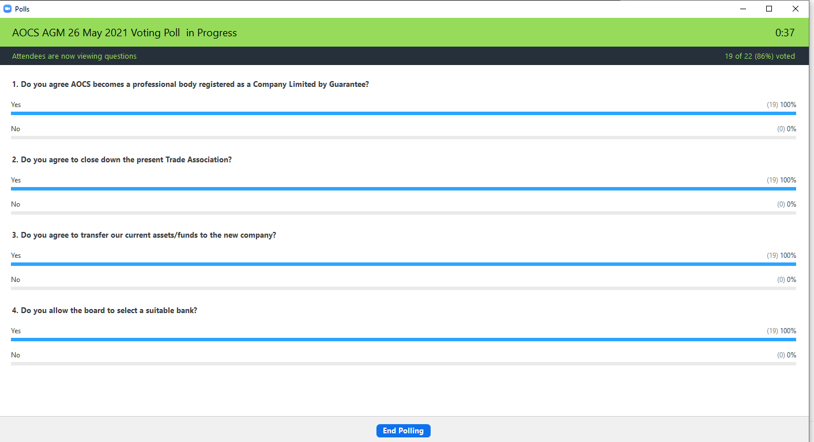
Action: the Transition Team will now set up the new company and close down of the Trade Association over the coming months, complete the required documents (memorandum of articles) with the accountancy company appointed. A new bank account will be chosen and our funds transferred over.
Once ready, the team will advise all members and of their limited liability, make changes to the website, and issue a press release.
The second part of this meeting focused on electing members to core roles within the CLbG.
Nominations and their mini-profiles had been issued prior to this meeting. The nominations were:
- Chair Elect: Lorenza Clifford (Discovery Group, Climate Change experience)
- Treasurer: Jenny Brown (with Governance and board member experience)
- Board appointment: D&E Accountancy, based in UK, because of their successful record in registering new companies, experience in this specialist field, and the ease of working with them (as recommended by Prof Stephen Palmer); their quote was extremely reasonable for both company registrations and for bookkeeping, so accepted for both capacities.
Following brief statements about what each would bring to their respective roles, the members were again asked to vote using Zoom Polling.
Result: 100% agreement in favour of electing those nominated. The Transition Team thanked the members for their support for both Lorenza and Jenny.
Action: Lorenza and Jenny are elected with immediate effect to these roles. Both will work with the Transition Team over the coming months to put the new organization in place and effect a smooth transition over the summer months.
Various vacant board member roles and volunteer opportunities
Lastly, Peter and Lorenza outlined both board member and volunteer roles that are needed to be filled swiftly.
Special thanks were made to Jo Birch and Julia Menaul for their valued recent contributions to the board, and to Yvette Elcock for her sterling work on communications, Discovery Group, social media, co-supervision where she will continue alongside Michelle Lucas etc.
Board roles, probably 4-6, would be generic – policy making, decision making, providing continuity and good communications to members, etc. and also allow for specialist areas of responsibility, such as:
Strategy, Governance, Membership, Climate Change, Diversity and Inclusion, Communications and social media, Volunteer leading, Partnership and Research. Whilst it is aspirational to fill all of these roles, it was recognised that it was important to fill core roles first.
Some additional points were made:
Role-sharing was available; deputies and understudies were both welcome and advisable; ok to bring your own contacts of trusted helpers as excellent way to develop someone with less profile at present.
Action: as time to appoint people and to discuss roles in detail was limited in this meeting, some separate follow up meetings will be arranged (using Doodle poll) end of June.
Feedback at the end of the meeting included:
- I would like to applaud the existing board and Stephen for today - really well thought through and presented.
- Encouraging to hear such robust and nuanced views/intentions, so thanks for time and attention on behalf of AOCS.
- Well done to everyone involved in today. Thank you to those who have led the organisation thus far and best of luck to Lorenza and Jenny and co in the future.
- Excellent to be with everyone this morning and witness the new direction and look forward to contributing to continued success. Thank you.
- Thank you so much everyone, congratulations to the new team. Onwards and Upwards!
- Thank you. Very well organised and run meeting. Congratulations to Lorenza and Jenny.
- All looking great! Good to see you all.
- Thanks and Kudos to Lorenza and Jenny for stepping up.
- Peter was thanked for his clear and effective facilitation of this meeting in addition to all his previous accomplishments for our association.
Peter thanked everyone for participating and for contributing to these important decisions on behalf of AOCS members.
Meeting ended at 14.00 BST.
Minutes drafted by Peter on 26/5/21.
Small amends by Lorenza on 27/05/2021

